Circuit Switching Network: Ex: the early analog telephone network. When a call is made from one telephone to another, switches within the telephone exchanges create a continuous wire circuit between the two telephones, for as long as the call lasts.
Base 10 powers for bit per second transfers 2^10=1024, 2^20= 1048576 (kibi,mebi,gibi)
Types of Delay:
- Propagation Delay: signal travels fast over links but not infinitely fast
  - t_{prop} : distance divided by propogation rate. Prop Rates: [Copper: 2.3* 10^8 ][Wireless: 3.0 * 10^8]
- Transmission Delay: bits can only be pushed onto a link at a certain rate, limited by the hardware powder
  - t_{xmit} : transmit the bits onto the link: L bits of date with R bandwidth (in bps). L/R seconds to transmit.
- Queuing Delay: packet switches along the way may incur delay because of packets in outgoing queue
  - t_{queue :} Hard to quantify. Heavy traffic = larger delay, if queue is empty near instant transmission to line.
- Processing Delay: Packet switches take some time to determine to which the outgoing interfaces to route the packet
  - t_{proc} : protocol dependent, higher for TCP than UDP, etc.
- Full Calculation for a single node: t_{nod} = t_{proc} + t_{queue} + t_{xmit} + t_{prop}
  - Small transmission → propagation important, large transmission → bandwidth is important
Round Trip Time (RTT): time back and forth to node
Link Utilization: Capacity = propogation delay * bandwidth = bits
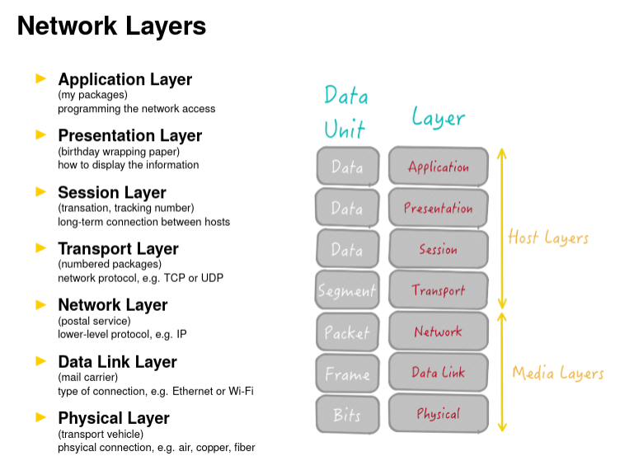
Email Components & other initialisms:
- message user agent (MUA): email client / local server
- message handling service (MHS): composed of message transfer agents
- message transfer agents (MTA): responsible for exactly 1 application level hop
- mail submission agent (MSA): accepts messages by the MUA
- mail delivery agent (MDA): delivers the message to the message store
- message store: keeps messages until MUA retrieves them.
- Simple Mail Transfer Protocol (SMTP): move messages between MTA’s ascii text commands, 4 letter long cmds, short and simple. RFC 821, RFC 5321. Port 587
- Post Office Protocol (POP) : similar to SMTP, RFC 1939, POP3S (secure TLS), Starts with +OK/-ERR
- Internet Message Access Protocol (IMAP):
- Multipurpose Internet Mail Extensions (MIME Types): MIME-Version:, Content-Type, Content-Transfer-Encoding, Content-ID, Content-Description.
UDP Packet:
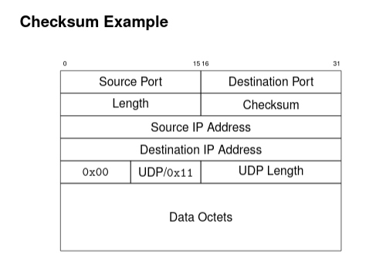
SYN/ACK
Timeouts
Automatic Repeat reQuest (ARQ)
Stop-and-Wait Protocol
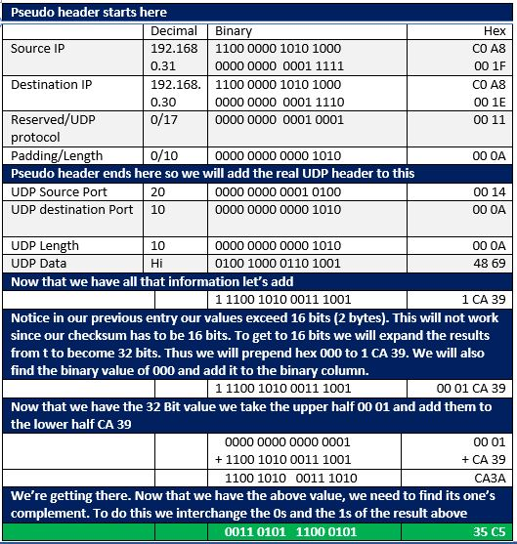
Sliding Window Protocol:
- Sequence Numbers
- Sending Window Size (SWS) => (RTT * Bandwidth / Packet Size).
  - When RWS = SWS => SWS < ((MaxSeqNum + 1)/2)
- Last ACK received (LAR)
- Last Frame Sent (LFS)
- Sender Responsibility: LFS -LAR < SWS
- Receiving Window Size (RWS) => Often = 1 or = SWS
- Largest Acceptable Frame (LAF) => LFR + RWS
- Last Frame Received (LFR) => SeqNumToAck
- Receiver Responsibility: LAF – LFR > RWS
- if (SeqNum <= LFR ) OR (SeqNum > LAF) THEN: discard
TCP:
- Common Flags:
  - SYN (establish), FIN (Finish), ACK (Acknowledgment), URG(Urgent), PUSH(pass immediately), RESET(Softly abort connection)
- Assumptions:
  - Sender:
    - Last Byte Sent <= Last Byte Written
    - Last Byte Ack’d <= Last Byte Sent
  - Receiver:
    - Last Byte Read < Next Byte Expected + 1
  - Advertised Window: size of the window or number of unacknowledged bytes
  - Max Send Buffer & Max Receive Buffer: Max bytes that can be waiting
  - Effective Window: Actual window size by considering bytes in transit
- Last Byte Received – Last Byte Read <= Max Receive Buffer
- Advertised Window = Max Recv Buffer – (Next Byte Expected – 1 – Last byte Read)
  - Last Byte Sent – Last Byte ACK’d <= Advertised Window
- Effective Window = Advertised Window – (Last Byte Sent – Last Byte ACK’d)
  - Last Byte Written – Last Byte ACK’d <= Max Send Buffer
  - Last Byte Written – Last Byte ACK’d + y > Max Send Buffer
    - TCP blocks sending process
- Maximum Segment Size (MSS): usually set to size of largest TCP segment
- Maximum Transmission Unit (MTU): Max of direct connected unit minus TCP/IP headers
- Algorithims:
  - Nagle’s (John Nagle): self-clocking,
    - if there is data to send: {if window size >= MSS & avail data >= MSS; then:{ send complete MSS}; else{if there is unconfirmed data: {enqueue data} else{send data immediately}}}
    - Turn off with “TCP_NODELAY”
- Adaptive Retransmission:
  - EstRTT = \alpha * EstRTT + (1 - \alpha) * SampleRTT, where \alpha is between 0.8 and 0.9
  - Timeout = 2 * estRTT
  - Algorithims:
    - Jacobson/Karels:
      - Difference = SampleRTT – EstRTT
      - EstRTT = EstRTT + δ * Difference. Where δ is between 0 and 1
      - Deviation = Deviation + δ * (abs(Difference) – Deviation)
      - Timeout = μ * EstRTT + γ

